Aman Patel

September 21, 2018

UROC@SICE

Mohsen Sayyadiharikandeh

Week One: Getting Familiar with Wikipedia API

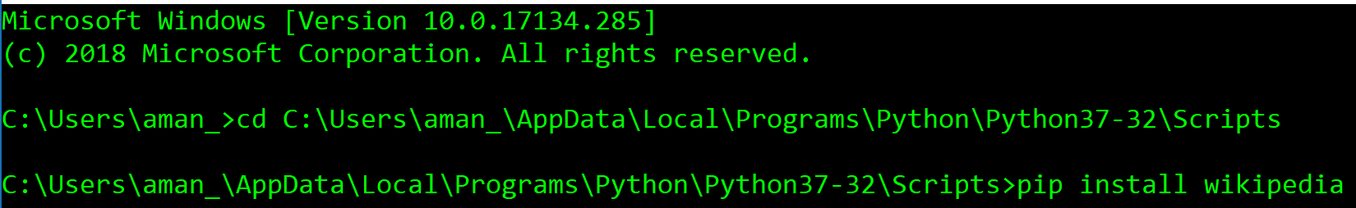 This week I was tasked with getting familiar with Wikipedia API. I started by downloading Python 3.7.0 from Python.org. Then, using a tutorial found on YouTube, I installed the Wikipedia API using the pip script. This process involved accessing the Scripts folder from the command line and installing Wikipedia using pip.

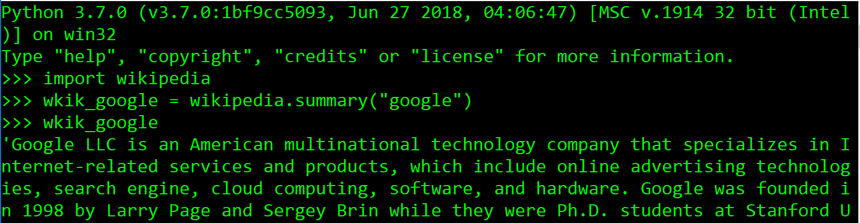Once the install was complete, I opened Python and imported Wikipedia. Then, using an online guide to Wikipedia API Python, I explored some of the different functions of Wikipedia API.

I extracted the summary of an article.

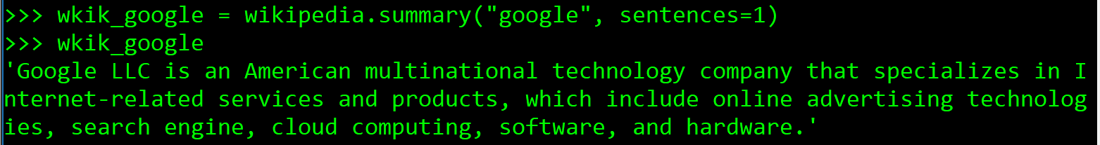I extracted the first sentence of the summary of an article.

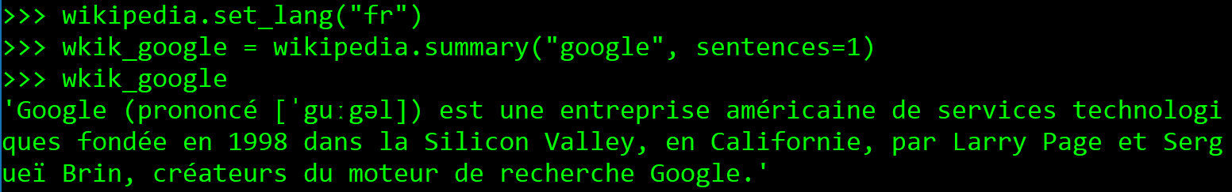I changed the language of the article to French and printed the first sentence of the article.

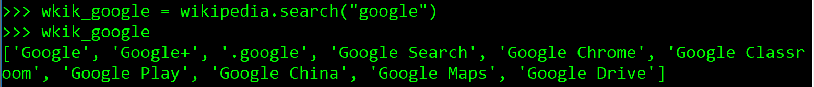I searched for the titles of an article.

I extracted the URL from an article.

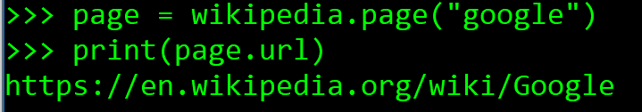

I extracted the title of an article.

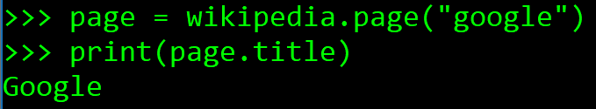

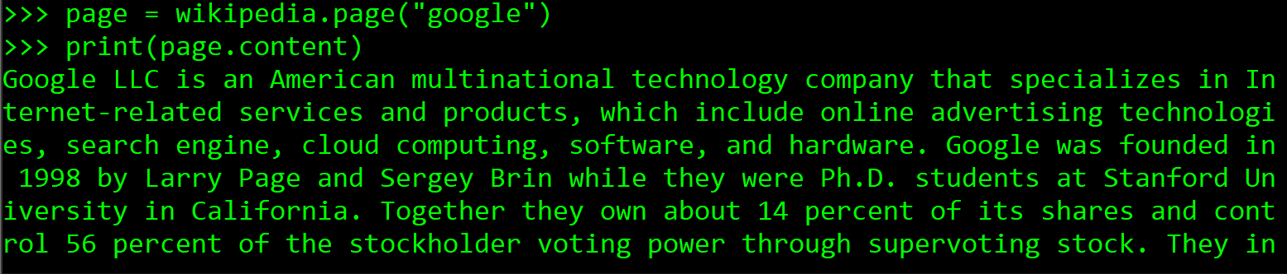I extracted the complete text of an article.

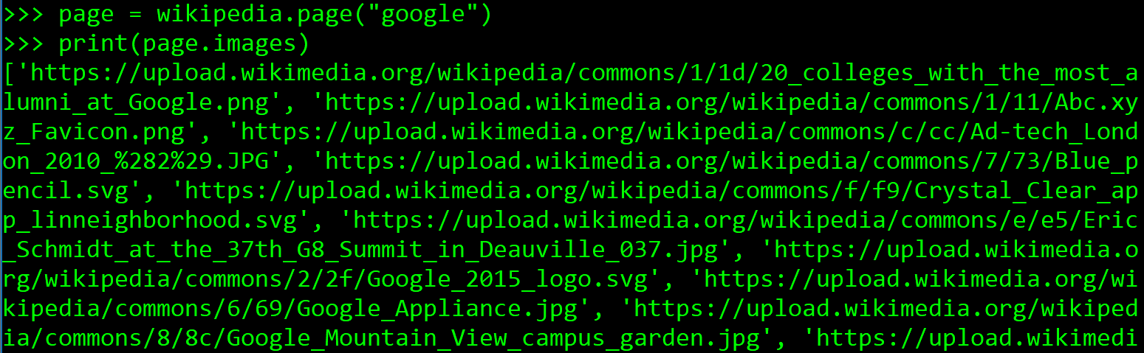Finally, I extracted the images included in an article.

Works Cited

Robert PNLP. “How to Install Python Wikipedia API.” *YouTube*, YouTube, 4 Mar. 2018, [www.youtube.com/watch?v=9_9YJUplTAU&list=LLc_6Mp5k6P-jl50kRg_zpgA&t=0s&index=2](http://www.youtube.com/watch?v=9_9YJUplTAU&list=LLc_6Mp5k6P-jl50kRg_zpgA&t=0s&index=2).

Mishra, Neeraj. “Wikipedia API Python Tutorial.” *The Crazy Programmer*, 23 May 2018, [www.thecrazyprogrammer.com/2018/05/wikipedia-api-python-tutorial.html](http://www.thecrazyprogrammer.com/2018/05/wikipedia-api-python-tutorial.html).